Transition Iteration Plan 1

# 1. Key milestones

|  |  |
| --- | --- |
| **Milestone** | **Date** |
| Iteration start | 17/09/2018 |
| Team Meeting | 24/09/2018 |
| Iteration Meeting with Jim | 3/10/2018 |
| Iteration stop | 27/09/2018 |

# 2. High-level objectives

1. Complete Beta Testing.
2. Update User Manual

# Evaluation criteria

1. Each team member has had someone complete Beta Testing
2. User Manuals are complete

# 4. Work Item assignments

The following Work Items will be addressed in this iteration:

|  |  |  |  |  |  |  |  |
| --- | --- | --- | --- | --- | --- | --- | --- |
| **Work Item ID** | **Name or key words of description** | **Outcome** | **State** | **Assigned to (name)** | **Estimated Hours** | **Hours worked** | **Estimate of hours remaining** |
| 4.1 | Beta Testing | Each member should have had one person that they have been able to contact (Family, Friends, Associates) to complete Beta testing in order to try and identify bugs in the application, or usability issues | Completed  Testing done | Ryan  Lenny  Beau  Jette | 10 | 0 | 10 |
| 4.2 | Update User Manual | Remove unnecessary redundant information and whitespace | [Complete](https://bitbucket.org/itc303teampharmacon/pharmacy_app/src/master/documents/User%20Manual/UserManual.pdf) | Jette | 5 | 5 | 0 |
| 4.3 | Survey for Beta Testing Round 2 | Survey users to identify that issues found in Round 1 have been dealt with and can be signed off | Incomplete | Ryan  Lenny  Beau  Jette | 2 | 0 | 2 |

# 5. Issues

|  |  |  |
| --- | --- | --- |
| **Issue** | **Status** | **Notes** |
| Database not responding | Resolved | The database had been dropped for some reason, on inspection we were unable to identify why this was the case. In order to rectify the issues with the database, all of the database scripts were run to rebuild the schema, tables, and reinsert the data. |

# 6. Assessment

[[Use this section for capturing and communicating results and actions from assessments, which are typically done at the end of each iteration. . . If you don’t do this, the team may not be able to improve the way they develop software.]

|  |  |
| --- | --- |
| Assessment target | Completed transition |
| Assessment date | 15 October 2018 |
| Participants | Ryan, Beau, Lenny, & Jette |
| Project status | **Green** |

## Assessment against objectives

## Work Items: Planned compared to actually completed

## Assessment against Evaluation Criteria Test results

## Other concerns and deviations

Investigation into the disappearance of the P.E.T. database has discovered that the application has been hacked by persons unknown. Following are screenshots of the investigation.

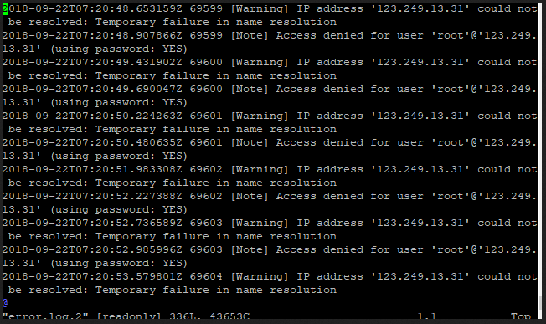

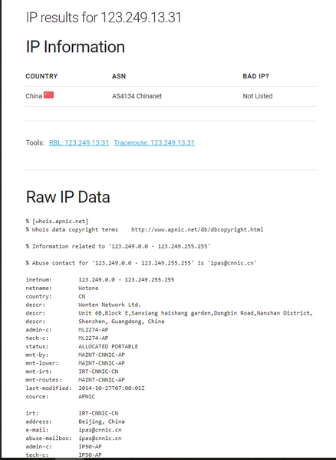

Initially IP 123.249.13.31 attempted a number of times to connect to the database using the root account without success, this resulted in moving to where the logs had error messages and back tracking to the last access before the errors began.

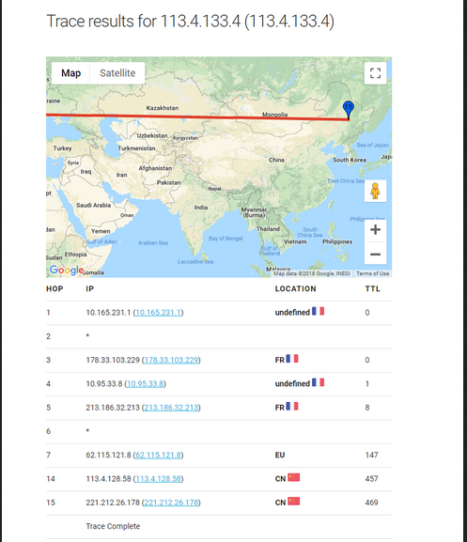

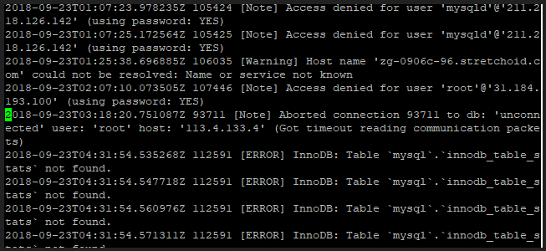

As can be seen above the address: 113.4.133.4 was connected to the database as user root and got a timeout, it is assumed that this address was the address that dropped all of the tables in the database. This can then be seend with MySQL having issues with the InnoDB engine trying to talk to mysql.innodb_table_stats.

.